Zhou Yuanyu

222040002

**Grid trading strategy**

Assignment 3

**ABSTRACT**

This strategy selects ETF funds for grid trading, sets the grid trading size according to the characteristics of the net value of the fund, buys and sells shares every time it crosses the network line, and takes profit and stop loss operations, hoping to achieve excess returns on the original fund.

**Key words：ETF funds, grid trading**

**Contents**

1. Introduction to the policy 1

2. Policy enforcement 1

2.1. Select the target 1

2.2. Open a bottom position 2

2.3. Set the grid size 2

2.4. Set the share per cell 2

2.5. Set the trading hours 2

3. Advantages and disadvantages of grid trading 3

3.1. Advantages 3

3.2. Disadvantages 3

4. Policy attempts 4

References 4

# **Introduction to the policy**

Grid trading revolves around the benchmark price, and whenever the price falls, a buy operation is performed at the trigger point; Whenever it rises, a sell operation is performed at the trigger point. The core idea of grid trading is that if a security is in a swing swing, it can seek to attract chips at a low level and release chips at a high level, so as to repeat the cycle in order to obtain excess returns.

The grid trading method essentially uses the strategy of low absorption and high selling. That is, first choose the target to buy a certain bottom position, set a price fluctuation range (lowest price ~ highest price), and divide the fluctuation range into N equal parts (difference), buy one for each price difference that falls, sell one for each price difference that rises, and sell one for low absorption and high selling to earn the band difference.

# Policy enforcement

## 2.1. Select the target

(1) Choose the target that can be traded in the stock account: because grid trading requires high-frequency trading and real-time trading, over-the-counter funds are not very suitable;

(2) Choose a target with a stable long-term market or high certainty of upward growth: no long strategy can be profitable in a unilateral downward trend;

(3) To choose a variety with greater volatility: the yield of the grid depends on the volatility of the variety, the stronger the volatility, the greater the possibility of touching the buy and sell line, the more times it is sold, the more profit will be cashed out.

(4) Choose the variety with the lowest possible transaction fee: Under frequent transactions, it is necessary to choose the variety with the lowest possible transaction fee, otherwise the income will be eaten by the handling fee.

The best target to meet these conditions is the index ETF fund, because the index ETF has a small probability of stepping on the pit, the transaction fee is low and does not pay stamp duty, and the long-term rise certainty is higher than that of individual stocks, followed by convertible bonds, or some large-cap blue chips.

## 2.2. Open a bottom position

The first step is to build a floor position for grid trading, the size of which is based on the market valuation, if the current valuation is low, the floor can be slightly increased, and the higher valuation can be light.

Taking the food and beverage ETF as an example, (let's say) the current price is about 1 yuan, I think the current valuation is reasonably undervalued, assuming that there is 30,000 yuan of funds on hand, so you can use 20,000 shares of the food and beverage ETF with a current price of about 1 yuan as a bottom position, and the remaining funds will not move temporarily as activity funds.

## 2.3. Set the grid size

According to the recent trend, there is not much room for decline, so we set the bottom price of the food and beverage ETF to 0.7 yuan, the price interval to 0.05 yuan (it can also be set as a proportion, here is a convenient example), and the top price is set to 2 yuan. That is, for every $0.05 down, buy 1 copy, sell one for every 0.05 yuan rise, and suspend trading if the price falls below $0.7 or rises by $2.

## 2.4. Set the share per cell

In order to prevent the net breaking, the size of each cell needs to be calculated according to the available fund balance and the lower limit of the grid price: if the market falls unilaterally, then the remaining funds of 10000 can be bought exactly 2000 shares at the closing price of 0.95, 0.90, 0.85, 0.75, 0.7 (can also be bought and sold at a fixed amount, which is convenient here and does not constitute investment advice).

## 2.5. Set the trading hours

For convenience, we directly set the strategy to be effective for a long time, as long as the net is not broken, the grid trading strategy will always keep running, constantly fluctuating the wool of the market.

# Advantages and disadvantages of grid trading

## 3.1. Advantages

First, buy in batches, improve the error tolerance rate, and reduce the impact of one-time investment. Grid trading divides funds into multiple parts and buys them in batches, greatly reducing the requirement for buying points.

Second, increase positions in declines and reduce holding costs. Within the set grid, the grid trades are buying more and more down. Constantly buying at a low level, even if it is in a state of continuous loss, but the overall holding cost is constantly decreasing, once the market rebounds, the accumulated lower cost can easily generate profits. Moreover, the shares of the transactions in the grid correspond one to one, as long as there is a rebound, it meets the requirements of the grid and immediately sells to get the spread profit of the corresponding share.

Third, the operation is simple, easy to execute, and reduce the emotional impact. Grid trading is also very friendly for office workers and people who usually have less time. Just take a moment to set up the grid, followed by a comfortable trading process, waiting to buy, waiting to sell, and not needing to pay attention to the market for a long time.

## 3.2. Disadvantages

Falling below the minimum price is prone to losses. The grid trading method works best in the bottom oscillating area and is more secure. However, the market is unpredictable, often contrary to investors' judgment, when it falls, it may accelerate its decline, and when it falls below the lowest price, it is recommended to stop the market in time.

The unilateral market returns in the bull market are not high. Because the position is often short after breaking through the highest price, you should change the trading strategy or enlarge the grid space in time when facing a unilateral market.

The use of funds is not efficient. Grid trading itself is a trading strategy of gradual buying and gradual selling, which will lead to the utilization rate of the overall funds at about 60%~70%, and the final profit is limited.

Unfriendliness to human manipulation of trading. The grid trading method is a pure machine quantitative trading, after setting the indicator parameters, the system helps investors to monitor the market in real time, once the price is found to trigger the parameter conditions, directly execute the buy and sell.

# Policy attempts

Select 515800. OF is an ETF fund as an example, the strategy starts on January 1, 2020 and ends on April 15, 2023. Use crawlers to crawl the net value data of funds on the daily fund website.

The grid size is set at one-twentieth of the half-year volatility of the price, and 50 funds are bought and sold each time they cross the grid line, the initial purchase amount is 2,000 yuan, and the amount available in the account is 8,000 yuan. If the investment amount exceeds the total amount of the account, 1/3 of the existing shares are sold. For the take profit and stop loss operation, if the yield <=-0.3, sell 1/2 of the existing share, if the yield >=0.7, sell 1/2 of the existing share.

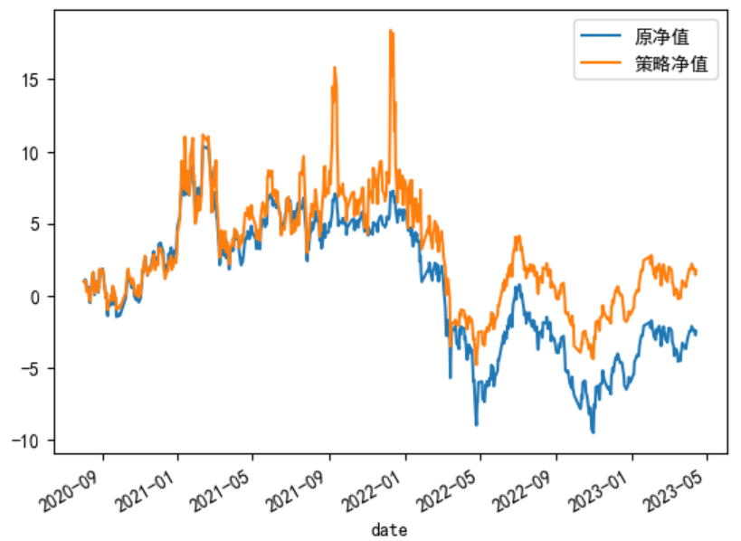

# References

[1]富国基金股票 ETF 投资策略探析 网格交易策略